Session 2026-2027

Vision:Dream of where you want. | Mission: Means to achieve Vision

Program Educational Objectives of the program (PEO): (broad statements that describe the professional and career accomplishments)
PEO1 | Preparation | P: Preparation | Pep-CL abbreviation  pronounce as Pep-si-lL easy to recall
PEO2 | Core Competence | E: Environment (Learning Environment) | Pep-CL abbreviation  pronounce as Pep-si-lL easy to recall
PEO3 | Breadth | P: Professionalism | Pep-CL abbreviation  pronounce as Pep-si-lL easy to recall
PEO4 | Professionalism | C: Core Competence | Pep-CL abbreviation  pronounce as Pep-si-lL easy to recall
PEO5 | Learning Environment | L: Breadth (Learning in diverse areas) | Pep-CL abbreviation  pronounce as Pep-si-lL easy to recall

Program Outcomes (PO): (statements that describe what a student should be able to do and know by the end of a program)
Keywords of POs:
Engineering knowledge,Problem analysis, Design/development of solutions,Conduct Investigations of Complex Problems, Engineering Tool Usage, The Engineer and The World,Ethics, Individual and Collaborative Team work,Communication, Project Management and Finance, Life-Long Learning

PSO Keywords: Cutting edge technologies, Research

“I am an engineer, and I know how to apply engineering knowledge to investigate, analyse and design solutions to complex problems using tools for entire world following all ethics in a collaborative way with proper management skills throughout my life.” to contribute to the development of cutting-edge technologies and Research.

Integrity: I will adhere to the Laboratory Code of Conduct and ethics in its entirety.

Name and Signature of Student and Date
(Signature and Date in Handwritten)

Session | 2024-25 (ODD) |  | Course Name | Web Technology Lab
Semester | 3 |  | Course Code | 23CT1301
Roll No | 79 |  | Name of Student | Gaurav Pekde
Practical Number |  | 2
Course Outcome |  | - Understand various internet technologies.  - Design the web pages using HTML and CSS.  - Implement the XML technology to store the data.  - Develop the interactive web pages using JavaScript.
Aim |  | Create a web form by using form tags in HTML
Problem Definition |  | Making a Student Registration Form in HTML using the form controls such as text boxes, radio buttons, checkboxes, text areas, drop-down menus, file upload, and action buttons.
Theory  (100 words) |  | HTML forms collect user input and submit it to a server or process it locally. Key elements include:  - <form>: The container element for all input components.  - <input>: A flexible tag whose type attribute determines the control (e.g., text, date, radio, checkbox, file, password, submit, reset).  - <textarea>: A multi-line text field for entering details like addresses.  - <select> and <option>: Creates drop-down selection menus.
Procedure and Execution  (100 Words) |  | Step for Implementation:  Open a text editor (such as VS Code, Notepad, or Notepad++).  - Create a file named student_registration.html.  - Add the basic HTML boilerplate structure (<html>, <head>, <title>, <body>).  - Add a centered title heading using <h1>.  - Enclose all input elements inside a <form> block.  - Include inputs for text fields (Name, Email, Mobile), date pickers (DOB), radio options (Gender), checkboxes (Hobbies), drop-down lists (Course selection), file attachments, and passwords.  - Add Submit and Reset buttons at the bottom.  - Open the .html file in a web browser to verify layout and form interaction.
<!DOCTYPE html>
<html lang="en">
<head>
<meta charset="utf-8">
<title>Student Registration Form</title>
<style>
* {
box-sizing: border-box;
}

body {
font-family: Arial, Helvetica, sans-serif;
background: linear-gradient(135deg, #c3cfe2 0%, #c5d9ed 100%);
margin: 0;
padding: 30px 15px;
}

.form-container {
max-width: 520px;
margin: 0 auto;
background-color: #ffffff;
padding: 25px 30px;
border-radius: 10px;
box-shadow: 0 4px 15px rgba(0, 0, 0, 0.15);
border-top: 5px solid #2980b9;
}

h2 {
text-align: center;
color: #2c3e50;
margin-top: 0;
margin-bottom: 20px;
padding-bottom: 8px;
border-bottom: 2px solid #ecf0f1;
}

fieldset {
border: 1.5px solid #bdc3c7;
border-radius: 8px;
padding: 18px;
background-color: #fafbfc;
}

legend {
font-weight: bold;
color: #2980b9;
padding: 4px 12px;
background-color: #ebf5fb;
border: 1px solid #d4e6f1;
border-radius: 4px;
font-size: 15px;
}

label {
display: block;
margin-top: 12px;
margin-bottom: 5px;
font-weight: bold;
font-size: 14px;
color: #34495e;
}

input[type="text"],
input[type="email"],
input[type="tel"],
input[type="date"],
select,
textarea {
width: 100%;
padding: 9px 12px;
border: 1px solid #bdc3c7;
border-radius: 5px;
font-size: 14px;
background-color: #ffffff;
}

input[type="text"]:focus,
input[type="email"]:focus,
input[type="tel"]:focus,
input[type="date"]:focus,
select:focus,
textarea:focus {
border-color: #2980b9;
box-shadow: 0 0 5px rgba(41, 128, 185, 0.3);
outline: none;
}

.gender-options {
margin-top: 6px;
background-color: #ffffff;
padding: 8px 12px;
border: 1px solid #e0e0e0;
border-radius: 5px;
}

.gender-options label {
display: inline;
font-weight: normal;
margin-right: 18px;
cursor: pointer;
color: #2c3e50;
}

.gender-options input[type="radio"] {
margin-right: 5px;
}

textarea {
resize: vertical;
}

.btn-group {
margin-top: 22px;
display: flex;
gap: 12px;
}

input[type="submit"] {
flex: 1;
background-color: #27ae60;
color: white;
border: none;
padding: 11px;
font-size: 15px;
font-weight: bold;
border-radius: 5px;
cursor: pointer;
}

input[type="submit"]:hover {
background-color: #219150;
}

input[type="reset"] {
flex: 1;
background-color: #e74c3c;
color: white;
border: none;
padding: 11px;
font-size: 15px;
font-weight: bold;
border-radius: 5px;
cursor: pointer;
}

input[type="reset"]:hover {
background-color: #c0392b;
}
</style>
</head>
<body>

<div class="form-container">
<h2>Student Registration Form</h2>

<form action="#" method="post">
<fieldset>
<legend>Student Information</legend>

<label for="firstName">First Name</label>
<input type="text" id="firstName" name="firstName" placeholder="Enter first name" required>

<label for="lastName">Last Name</label>
<input type="text" id="lastName" name="lastName" placeholder="Enter last name" required>

<label for="rollNo">Roll Number</label>
<input type="text" id="rollNo" name="rollNo" placeholder="Enter college roll number" required>

<label for="email">Email Address</label>
<input type="email" id="email" name="email" placeholder="example@gmail.com" required>

<label for="phone">Phone Number</label>
<input type="tel" id="phone" name="phone" placeholder="Enter 10-digit mobile number" required>

<label for="dob">Date of Birth</label>
<input type="date" id="dob" name="dob" required>

<label>Gender</label>
<div class="gender-options">
<label><input type="radio" name="gender" value="male" required> Male</label>
<label><input type="radio" name="gender" value="female"> Female</label>
<label><input type="radio" name="gender" value="other"> Other</label>
</div>

<label for="department">Branch / Department</label>
<select id="department" name="department" required>
<option value="">-- Select Branch --</option>
<option value="CT">Computer Technology</option>
<option value="IT">Information Technology</option>
<option value="AIDS">Artificial Intelligence and Data Science</option>
<option value="ETC">Electronics and Telecommunication</option>
<option value="ME">Mechanical Engineering</option>
<option value="CE">Civil Engineering</option>
</select>

<label for="address">Permanent Address</label>
<textarea id="address" name="address" rows="3" placeholder="Enter your address"></textarea>

<div class="btn-group">
<input type="submit" value="Register">
<input type="reset" value="Reset">
</div>
</fieldset>
</form>
</div>

</body>
</html>

 |  | Output: 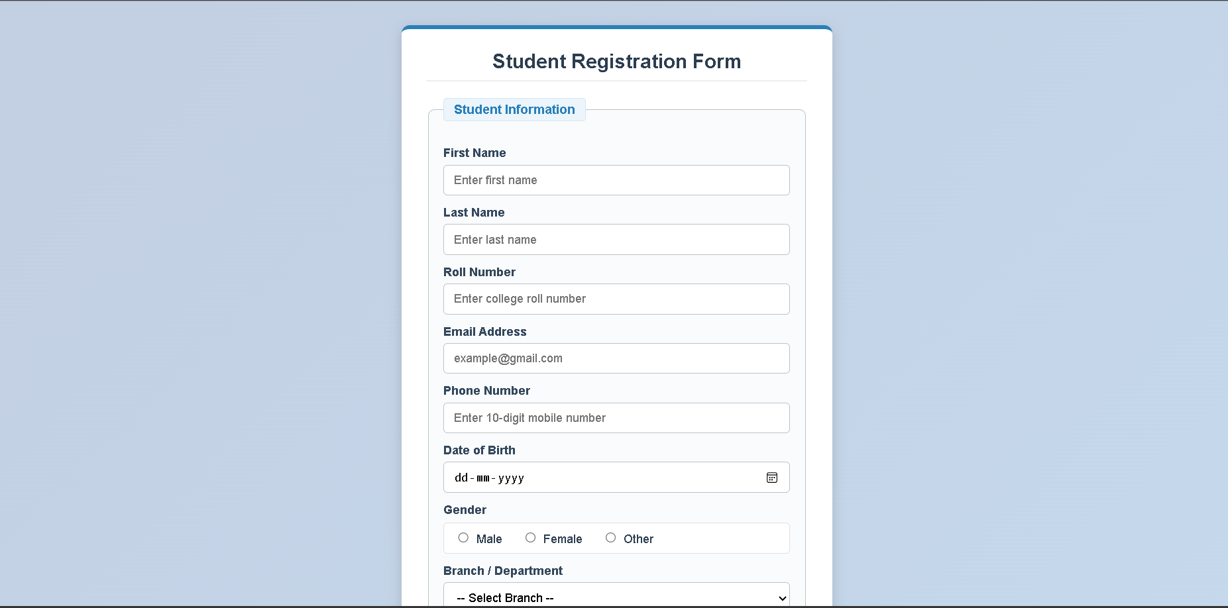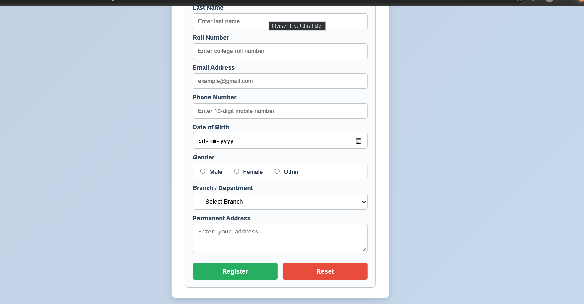
Output Analysis |  | Centered page title: Student Registration Form.  Form fields displayed sequentially: First/Last Name text boxes, Date selector, Gender radio buttons, Email/Mobile inputs, multi-line Address text area, Course dropdown menu, Hobby checkboxes, File upload button, and masked Password box.  - Interactive Register and Clear buttons at the bottom
Link of student Github profile where lab assignment has been uploaded |  | https://github.com/gauravpekde-sys/Web-Technology.git
Conclusion |  | The student registration web page was successfully constructed, displayed using standard HTML form tags, and verified in the browser.
Plag Report (Similarity index < 12%)
Date |  | 06/10/2026

